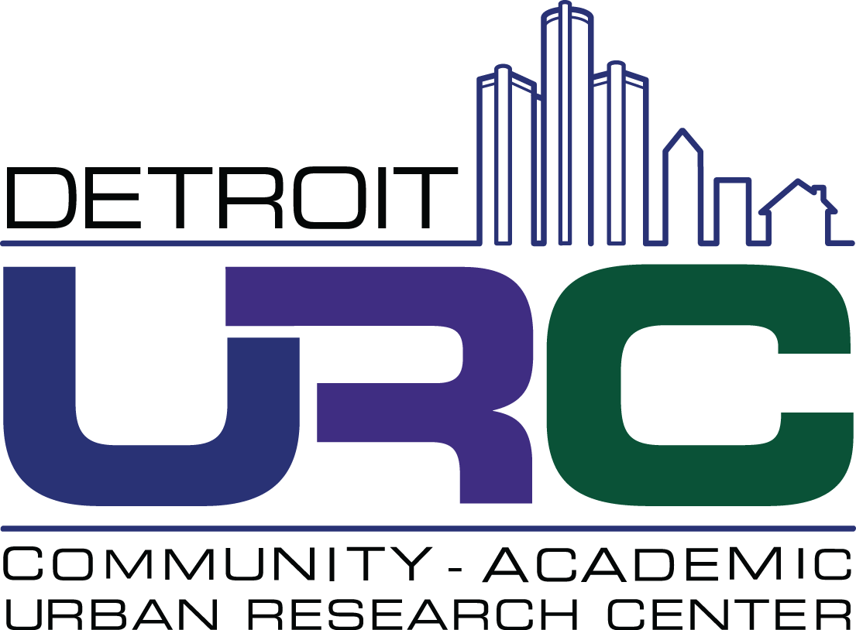

CBPR Partnership Academy 2022-2023
Pre-Application Worksheet

To help you prepare your online application for the Detroit URC’s CBPR Partnership Academy, we are providing this optional pre-application worksheet. It outlines all of the questions that are asked in the electronic application form.

COVER PAGE
- Name, Title, Organization/Institution, Number of Years with Organization/Institution, Academic Degree/Discipline, Organization/Institution Mailing Address and Phone Number, Email, Website (if applicable)

COMMUNITY PARTNER QUESTIONS
- What, if any, experience do you have collaborating with ACADEMIC RESEARCHERS to address health inequities? If you have had experience with CBPR, please describe it here.
(1800 characters max)
- Why are you interested in the CBPR Partnership Academy, and what do you hope to gain from it?
(1800 characters max)
- What, if any, challenges might you have participating in this year-long program, and how will you address them? (1800 characters max)
- In what ways is your organization embedded in and representative of the community with which this partnership will work and in what ways do you incorporate community voice in your work?
(1800 characters max)

ACADEMIC PARTNER QUESTIONS
- What, if any, experience do you have collaborating with COMMUNITIES and COMMUNITY-BASED ORGANIZATIONS to address health inequities? If you have had experience with CBPR, please describe it here. (1800 characters max)
- Why are you interested in the CBPR Partnership Academy, and what do you hope to gain from it?
(1800 characters max)
- What, if any, challenges might you have participating in this year-long program, and how will you address them? (1800 characters max)

TEAM QUESTIONS
- How long have you known each other and in what capacity? Please describe the nature and length of your working relationship.
(850 characters max)
- Please specify the stage of your partnership's development, select one:
  - CBPR Partnership will be formed in response to this application,
  - CBPR partnership early in development (less than 2 years),
  - Partnership established prior to this application but not using a CBPR approach,
  - Other (Please Describe)
- What are, or do you propose to be, the overall goals and objectives of your CBPR partnership?
(1800 characters max)
- How do you intend to apply the knowledge and skills gained through the CBPR Partnership Academy in your CBPR partnership?
(1800 characters max)
- Please describe the community that is/would be the focus of your partnership (for example, race/ethnicity, rural/urban/suburban, socioeconomic status, identity, strengths, concerns).
(1800 characters max)
  - What racial/ethnic populations does/will your partnership work with? [check all that apply]
    - Black or African-American
    - American Indian/Alaska Native
    - Arab American/Middle Eastern/North African
    - Asian American/Asian/Southeast Asian
    - Native Hawaiian or Other Pacific Islander
    - White/European American
    - Another identity not listed here
  - Do you consider the work of your partnership to be based/will be based in an urban, suburban, rural, and/or tribal environment? [check all that apply]
    - Urban
    - Suburban
    - Rural
    - Tribal
    - Other

SUPPORTING DOCUMENTS
- Community team member resume/CV
- Academic team member resume/CV
- Letter of support from a supervisor or equivalent (for community partner) showing support to participate in the one-year program including attendance at the week-long intensive course, July 10-15, 2022 or July 17-22, 2022
- Letter of support from an academic chair or equivalent (for academic partner) showing support to participate in the one-year program including attendance at the week-long intensive course, July 10-15, 2022 or July 17-22, 2022
PARTNER DEMOGRAPHIC QUESTIONS REQUIRED BY FUNDER (ANSWERED SEPARATELY)
- Do you identify as Latinx or Hispanic?
  - Yes
  - No
  - Prefer not to respond
- How do you identify yourself? Select all that apply.
  - Black or African-American
  - American Indian/Alaska Native
  - Arab American/Middle Eastern/North African
  - Asian American/Asian/Southeast Asian
  - Native Hawaiian or Other Pacific Islander
  - White/European American
  - Another identity not listed here
  - Prefer not to respond
- What is your gender identity?
  - Man
  - Woman
  - Transgender Female or Trans Woman
  - Transgender Male or Trans Male
  - Non Binary, Non-conforming, Gender Queer, or Gender Fluid
  - Another identity not listed here
  - Prefer not to respond
- Do you identify as having a disability?
  - Yes
  - No
  - Prefer not to respond

